PROJECT REPORT

ONLINE

CAKE BAKERY

SHOP

Purpose of the Project

The purpose of an online cake bakery shop is to provide customers with a convenientand accessible way to order and purchase cakes and other baked goods. By having an online presence, customers can browse through a wide variety of cake options, select the cake they want, and place an order from the comfort of their own house or office.

Online cake bakery shops typically offer a range of cakle flavours, design and size to choose from. Customers can also customize their cakes by adding special messages or requesting by specific decorations. In addition, online cake bakery shop often delivery services , making it easy for customers to recive their cakes at a convenient time and location.

Overall, the purpose of an online cake bakery shop is to make the process of ordering and purchasing cakes as easy and convenient as possible for customers while providing them with high-quality baked goods.

Scope of this Project

The scope of an online cake bakery shop is quite broad , as it has the potential to reach a large customer base and offer a wide range of baked goods. With the increasing popularity of online shopping and the convenience it provides, more and more people are turning to online cake bakery shops to order cakes and other baked goods for various occations.

One of the major advantages of an online cake bakery shop is that it can reach customers from all over the world . As long as the bakery offers delivery services to paricular location, customers can order from anywhere and have the cake delivered to their desired location.

Overall, the scope af an online cake bakery shop is quite vast, as it can cater to customers from all over the world, offer a wide varity of baked goods, and provide a personilzed shopping experience.

Requirements of Owner of this Project

An cake bakery website is neded for several reasons:

Online Presence: Having a website provides an online presence for the cake bakery. With a website customers can find information about the bakery including its location, hours of operation, menu and pricing. They can also place online orders , which is convenient for customers who cannot visit the bakery in person.

Increase Visibility: A webste also increase the visibility of the cake bakery. With the search engines like Google, making it easier for customers to find the bakery online.

Marketing: A website is a powerfull marketing tool. The bakery can use its website to promote new products, offers, discounts and run special promotions ton attract more customers

Customers Engagement: A Website allows the cake bakery to engage with customers in a variety of ways. Customers can leave reviews and feedback, signup for newslatters, and follow the bakery’s social media accounts.

Cost-effective: Having a website is cost-effective compared to traditional advertising methods. The bakery can reach a wider audience at a lower cost with a website.

Overall a cake bakery website is a valuable assert that can help attract more customers, increase revenue, and inhanced the Overall customers experience.

Refrences

Idea Generation: The Idea ofn creating a website came from seeing other websites.

Design Samples:Looked at other websites on the Internet for website sample, analyzed them and the prepared a sample by myself.

Content: Content is the most important things for a website. It has taken fom Google.

Error Solutions: Teachers, Books and Internet are many helpful for error solutions. Some websites are used W3schools, Codepen and GeeksforGeeks.

Tutorial:

Youtube Channels: Easy Tutorial, CarpoolVenom

Resources

Images: Pexels, Pixababy

Video: Pexels

Pages:

* Home Page
* Menu Page
* Gallery Page
* Contact Page
* About Page

Register Page Screenshot-

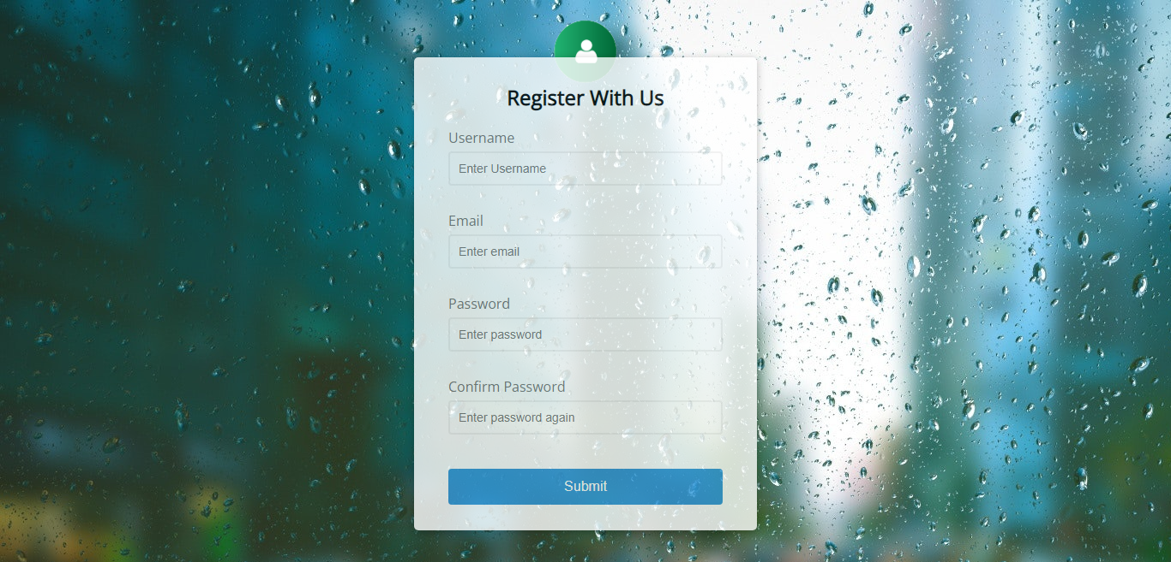

Coding

<!DOCTYPE html>

**<html>**

**<head>**

<meta charset="utf-8">

<meta name="viewport" content="width=device-width, initial-scale=1">

<title>Sign up</title>

<link rel="stylesheet" type="text/css" href="n2.css">

**<style>**

@import url('https://fonts.googleapis.com/css?family=Open+Sans&display=swap');

:root{

--succes-color: #2ecc71;;

--error-color: #e74c3c;}

*{

box-sizing: border-box;}

body{

background-image: url(backp3.jpg);

font-family: 'Open Sans', sans-serif; display: flex; align-items: center;

justify-content: center; min-height: 100vh; margin: auto;}

.pro img{

position: relative; height: 100px; width: 100px;align-items: center; margin- left: 100px; /*margin-top: -30px;*/ }

.pro{

border-radius : 10px 10px; position: absolute; height: 100px;/*

border: 1px solid black;*/transform: translate(-50px,-270px);}

.container{

background-color: #fff;border-radius: 5px;margin-top: 30px;

box-shadow: 0 2px 10px rgba(0,0,0,0.3); width: 400px;opacity: 80%;}

.form h2{

text-align: center;margin: 0 0 20px;}

.form{

padding: 30px 40px;margin-bottom: 10px;

padding-bottom: 20px; position: relative;}

.form-control label{

color:#777; display: block; margin-bottom: 5px; }

.form-control input{

border: 2px solid #f0f0f0;border-radius: 4px;padding: 10px;

display: block; width: 100%; font-size: 14px;}

.form-control input:hover{

cursor: pointer; box-shadow: 0 0 5px;

border-color: lightskyblue;

}

.form-control input:focus{

outline: 0; border-color: #777;}

.form-control.success input {

border-color: var(--succes-color);}

.form-control.error input {

border-color: var(--error-color); }

.form-control small{

color: var(--error-color); bottom: 0;

position: absolute;left: 0; visibility: hidden;}

.form-control.error small{

visibility: visible;}

.form button {

cursor: pointer;background-color: #3498db;padding: 10px;

border: 2px solid #3498db; display: block;font-size: 16px;

border-radius: 4px;color: #fff; margin-top:20px; width:100%;}

.form button:hover{

cursor: pointer;box-shadow: 0 0 5px;background: green;}

**</style>**

**</head>**

**<body>**

<div class="pro"><img src="pro1.jpg"></div>

<div class="container">

<form id="form" class="form" method="post"onsubmit="return submitClick()">

<h2>Register With Us</h2>

<div class="form-control">

<label for="username">Username</label>

<input type="text" id="username" placeholder="Enter Username" name="user_name">

<small>Error Message</small>

</div>

<div class="form-control">

<label for="email">Email</label>

<input type="text" id="email" placeholder="Enter email">

<small>Error Message</small>

</div>

<div class="form-control">

<label for="password">Password</label>

<input type="password" id="password" placeholder="Enter password">

<small>Error Message</small>

</div>

<div class="form-control">

<label for="password2">Confirm Password</label>

<input type="password" id="password2" placeholder="Enter password again">

<small>Error Message</small>

</div>

<button onsubmit="submit(href='wel.html')">Submit</button>

</form>

</div>

**</body>**

<script src="n3.js"></script>

**</html**

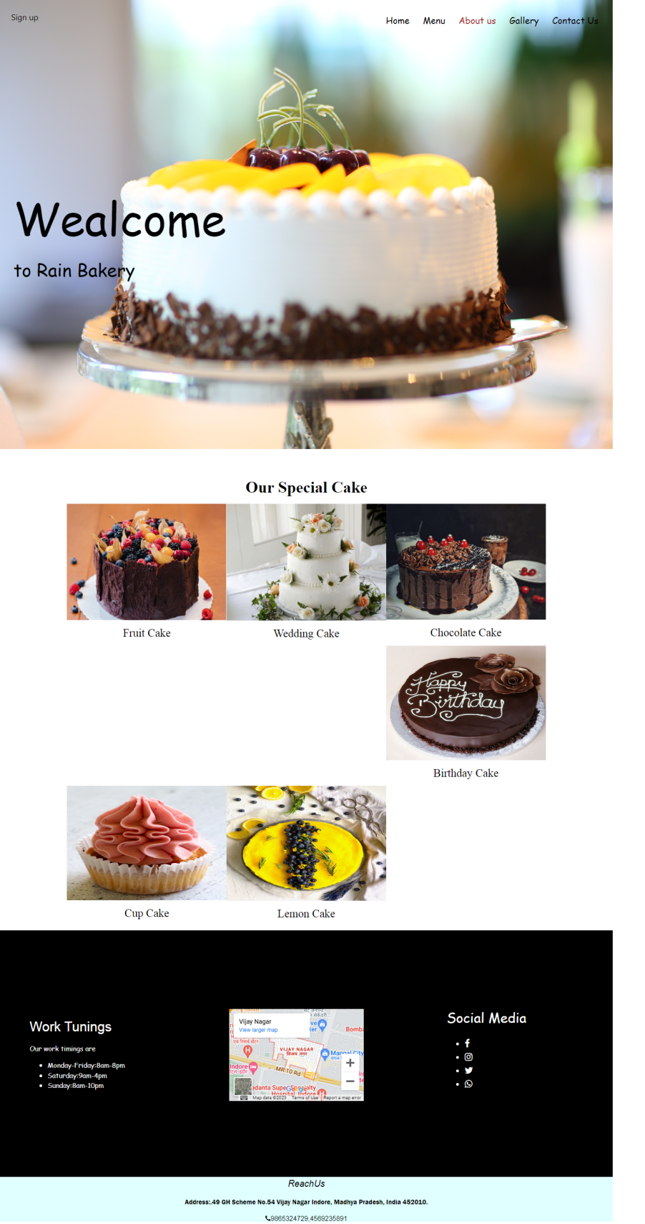

Home Page Screenshot

Coding

HTML

<!DOCTYPE html>

**<html>**

**<head>**

<meta charset="utf-8">

<meta name="viewport" content="width=device-width, initial- scale=1">

<title>project</title>

<link rel="stylesheet" type="text/css" href="style.css">

<link rel="stylesheet" href="https://cdnjs.cloudflare.com/ajax/libs/font-awesome/4.7.0/css/font-awesome.min.css">

<link rel="stylesheet" href="https://www.w3schools.com/w3css/4/w3.css">

<link rel="stylesheet" href="https://www.w3schools.com/lib/w3-colors-2021.css">

<!-- <link rel="stylesheet" href="https://fonts.googleapis.com/css?family=Karma"> -->

@import url('https://fonts.googleapis.com/css2?family=Poppins:ital,wght@0,300;1,300&display=swap');

**<style>**

body,h1,h2,h3,h4,h6 {font-family: 'Yeseva One', cursive;}

.w3-bar-block .w3-bar-item {padding:20px}

#ho:hover{

-webkit-transform: scale(0.1);

transform: scale(0.1);

-webkit-transition: .2s ease-in-out; transition: -2s ease-in-out;

-webkit-transform: scale(1.2); transform: scale(1.2);}

.sign{

position: absolute; display: flex; margin:10px;

padding: 5px;cursor: pointer; /*justify-content: space-between;*/}

.sign:hover{

border: 1px solid black; background: black;}

#list h5{

font-family: 'Times New Roman', serif; font-size: 25px;}

@Media(max-width: 550px){

ul li{

font-size: 5px;}

h1{

font-size: 20px;}

#container{

height: 500px;

width: 100%;}

#td{

transform: translate(300px,-120px);}

#td ul li{

font-size: 10px;}

#sd ul li{

font-size: 10px;}

footer{

height: 200px;}}

**</style>**

**</head>**

**<body>**

<div id="body">

<div id="container">

<a href="reg.html"><div class="sign">

<h5 style="margin:10px">Sign up</h5>

</div></a>

<div id="menu-items">

<ul id="ul">

<li><a href="home.html">Home</a></li>

<li><a href="menu.html">Menu</a></li>

<li><a href="about.html">About us</a></li>

<li><a href="gallery.html">Gallery</a></li>

<li><a href="contact.html">Contact Us</a></li>

</ul>

</div>

<img src="pexels-jasmine-lew-140831.jpg" id="ig" class="mySlides" style="width:100%">

<div id="text">

<h1 style="font-size: 100px;">Wealcome</h1>

<h3 style="font-size: 40px;">to Rain Bakery</h3>

</div>

</div>

<div class= "w3-container w3-main w3-padding w3-center w3-2018-meerkat" style= "margin-top: 40px;">

<h1 style="font-family: 'Times New Roman', serif;"><b>Our Special Cake</b></h1>

<div>

<div class="w3-row" style="max-width:80%; margin: auto;" id="list" >

<div class="w3-col l4 m6 s12 w3-center " id="ho" class="card2"><a href="menu.html">

<img src="pexels-geovane-souza-15071190.jpg" style="width:100%;" class="w3-hover-sepia" >

<h5>Fruit Cake</h5></div></a>

<div class="w3-col l4 m6 s12 w3-center" id="ho" class="card2"><a href="menu.html">

<img src="pexels-brent-keane-1702373.jpg" style="width:100%;" class="w3-hover-sepia"><h5>Wedding Cake</h5></a></div>

<div class="w3-col l4 m6 s12 w3-center" id="ho" class="card2"><a href="menu.html">

<img src="umesh-soni-LDnmyOaA-ew-unsplash.jpg" style="width:100%; height: 258px;"class="w3-hover-sepia"><h5>Chocolate Cake</h5> </div></a>

<div class="w3-col l4 m6 s12 w3-center" id="ho" class="card2"><a href="menu.html">

<img src="bir1.jpg" style="width:100%; height:255px" class="w3-hover-sepia"><h5>Birthday Cake</h5></div></a>

<div class="w3-col l4 m6 s12 w3-center" id="ho" class="card2"><a href="menu.html">

<img src="cup.jpg" style="width:100%; height: 255px;" class="w3-hover-sepia"><h5>Cup Cake</h5></div></a>

<div class="w3-col l4 m6 s12 w3-center" id="ho" class="card2"><a href="menu.html">

<img src="lemon2.jpg" alt="California Lemon Cake 6” Cake - Cheesecake@pngkey.com" style="width: 100%; height: 256px;" class="w3-hover-sepia" ><h5>Lemon Cake</h5></div></a>

</div></div></div>

<footer class="w3-row-padding w3-padding-32 w3-black"id="footer">

<div class="w3-third" id="sd">

<h3>Work Tunings</h3>

<div id="para"></div>

<p>Our work timings are

<ul>

<li>Monday-Friday:8am-8pm</li>

<li>Saturday:9am-4pm</li>

<li>Sunday:8am-10pm</li>

</ul>

</p></div>

<div class="w3-center" id="map"><div class="w3-top" style="font-size:20px; font-family: 'Poppins', sans-serif;sans-serif;"><h3>Our location</h3></div>

<iframe src="https://www.google.com/maps/embed?pb=!1m18!1m12!1m3!1d3679.335179746722!2d75.89112842409399!3d22.752939129363618!2m3!1f0!2f0!3f0!3m2!1i1024!2i768!4f13.1!3m3!1m2!1s0x396302af403406fb%3A0x5b50834b117f8bab!2sVijay%20Nagar%2C%20Indore%2C%20Madhya%20Pradesh%20452010!5e0!3m2!1sen!2sin!4v1681888232054!5m2!1sen!2sin" width="300" height="205" style="border:0; transform: translate(0px,-127px); position: relative;" allowfullscreen="" loading="lazy" referrerpolicy="no-referrer-when-downgrade"></iframe></div>

<div class="w3-third w3-serif <!-- w3-right -->" id="td">

<h3>Social Media</h3>

<div style= "justify-content: space-between;">

<ul>

<a href="www.facebook.com"><li><i class="fa fa-facebook"></i></li></a>

<a href="www.instagram.com"><li><i class="fa fa-instagram"></i></li></a>

<a href="www.twitter.com"><li><i class="fa fa-twitter"></i></li></a>

<a href="www.whatsapp.com"><li><i class="fa fa-whatsapp"></i></li></a>

</ul><div></div></footer>

<div class="bot"><h4 style="font-family: Gill Sans, sans-serif;"><i>ReachUs</i></h4>

<p style="font-family:Franklin Gothic Medium">Address:.49 GH Scheme No.54 Vijay Nagar Indore, Madhya Pradesh, India 452010.

<p><i class="fa fa-phone"></i>9865324729,4569235891</p></p>

</div> </div>

**</body>**

**</html>**

